Question 1.

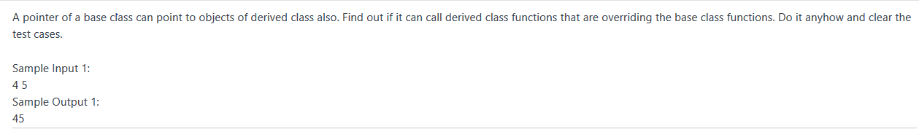

Question 2.

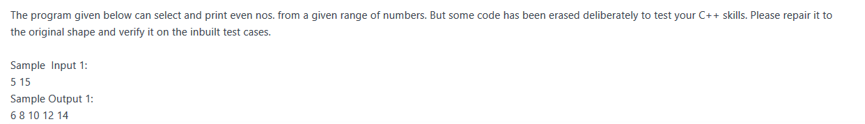

Question 3.

C:\Users\MANI\Pictures\Screenshots\Screenshot (5).png

Question 4.

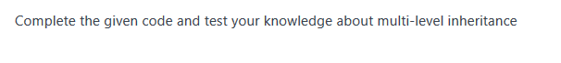

Question 5.

A class **bill** is inherited by two classes **cheque, cash** in **protected mode**.

**bill** class has two members **item_price,qty.**

The product of the two, 1. price of the item and 2. quantity will give us the **total bill**.

class **cheque** again has two members **cheque_no, cheque_amt**.

Write a member function to test whether the amount in the cheque clears the bill or not.

**if yes** put the word **"Clear" if no** put the balance amount as **"Balance=100" (100 is an example).**

**Similarly class cash** has 4 data members for the number of **notes of 500,100,10,1.**

**Total** is to be calculated from the notes and again **matched with the bill.**

If the bill is cleared with cash put the word **"Clear" if no** put the balance amount as **"Balance=100" (100 is an example).**

**Sample Input 1:**

1          // for cheque clearance

10        //item_price

10        //qty

1234    //cheque_no

80        // cheque_amt

**Sample Output 1:**

100                  //bill [item_price*qty]

Balance=20     //pending=100-80=20

**Sample Input 1:**

2          //for cash payment

10        //item_price

10        //qty

0          //notes of 500

0          //notes of 100

10        //notes of 10

0          //notes of 1

**Sample Output 1:**

Clear

Question 6.

A class **string1** allocates appropriate memory (using new operator) to a string

**passed from the main function**, and then decrypt the string, by subtracting 3 to

the ASCII value of each alphabet of the string.

**Sample Input:**

Deklodvkd

**Sample Output:**

Abhilasha

Question 7-

Given the following inheritance structure of classes that represents the student details, marks in 3 subjects and Result respectively, generate the sample output.

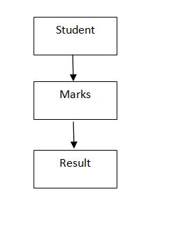

Question 8-

Write a program to enter basic information(name,empId,gender) and department information(dept name,assigned work,timetaken) for an employee and print the entire information using classes basicInfo, deptInfo  and employee classes.For Wrong values print "Wrong Input".

Constraint:

timetaken can't be zero or negative.

Sample Input:

rahul    //name  
101    //empID

m        //gender  
cse    //dept name  
dl    //assigned work  
45    //timetaken

Question 9-

 Write a program to calculate area of Square and Circle using classes Shape,Square and Circle.

Sample Input:

2

3

Sample Output:

Area of square: 4  
Area of circle: 28.26

Sample Output:

rahul  
101  
m  
cse  
dl  
4.5

Question 10 –

Write a program to calculate square and cube of a number N using classes Number,Square and Cube.

Constraint:

1<=N<=1000

Sample Input:

2

Sample Output:

Square of 2 is: 4  
Cube   of 2 is: 8

Question 11-

Write a program to calculate total result of a student by adding marks in two subjects and sports marks using classes Student,Sports,Test and Result.For wrong values print "Wrong Input".

Constraint:

all inputs are greater than 0

Sample Input:

2    //Roll Number  
3    // Marks in Sub 1  
4    //Marks in Sub 2

5    //Sports Marks

Sample Output:

Roll number 2  
Marks in sub1 3  
Marks in sub2 4  
Score 5  
total = 12

Question 12-

Write a program to calculate area of Square and Circle using classes Shape,Square and Circle.

Sample Input:

2

3

Sample Output:

Area of square: 4  
Area of circle: 28.26

Question 13-

Given the following inheritance structure of classes that represents the marks of one student in internal and external assessments of 3 subjects respectively and the Result class generates the rand total.

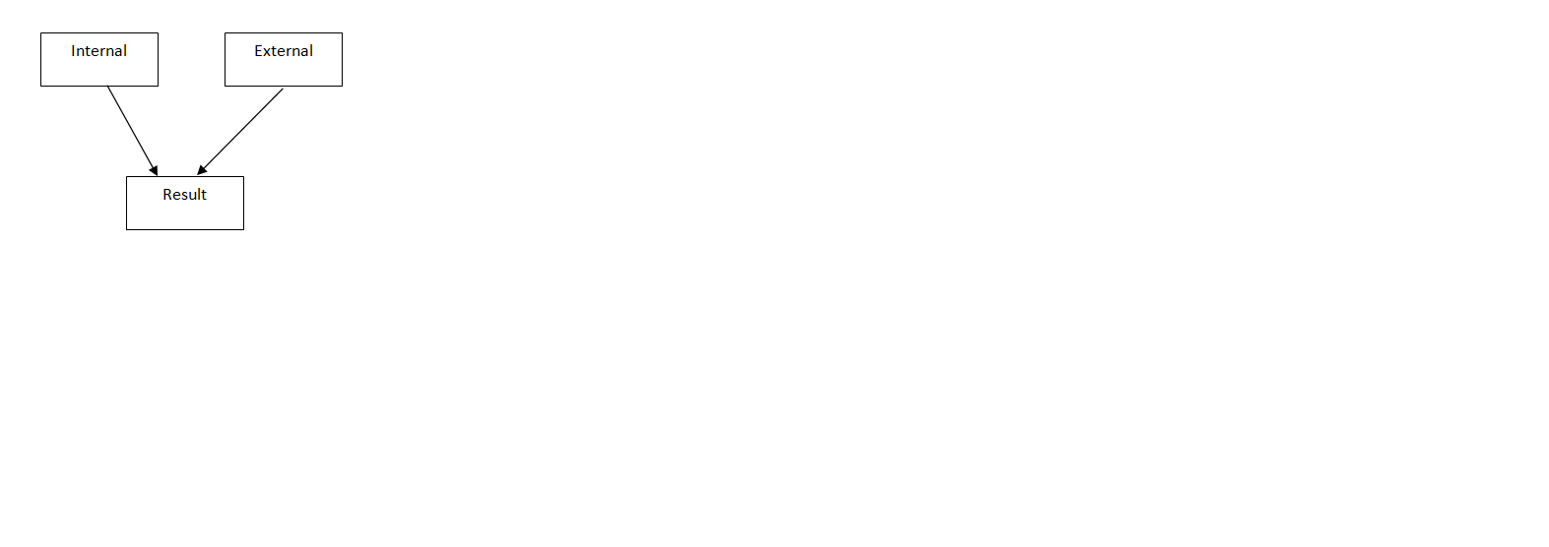

Sample Input:

12

34

56

10

20

30

Sample Output:

102

60

162

Question 14-

Base Class name bill has three data members: item_code, price, total.

Class cash is derived from bill having deno, value,  num and cheque is also derived from bill having chec_no,bank_name as data members.

The customer is having an option to buy from cheque or cash.

Sample Input:

//Number of items

5

//itemcodes and prices

1

10

2

10

3

10

4

10

5

10

//Option Cheque/cash

2

//Num of Denominations

3

//1st Denomination

Rs. 100

//value of 1st Denomination

2

//2nd Denomination

Rs. 50

//value of 2nd Denomination

2

//3rd Denomination

Rs. 10

//value of 3rd Denomination

2

Sample Output:

//Total

50

notes=3

100

2

50

2

10

2

Question 15-

employees of some particular bank want an application interface for performing cash transaction online so they have created an app . Create a class named employee with data members --account_no(long int), balance and member function void get_data() and void display_data().

Class beneficiary has data member- b_acc_no(long int) , b_bal and b_amt. member function of this class are void get_b_data() and void transfer() and void print().

transfer function is used to transfer amount from employee account to beneficiary account . If amount to be transferred is less than employee's balance then print "insufficient balance".

Sample input:

12345    //employee acc no

2000    //balance

19876    //beneficiary acc no

1000    // balance in beneficiary acc

500       // amount to be transferred

Sample output:

12345

1500        //500 deducted from employee

19876

1500        //500 added to beneficiary

Question 16-

Raj works in two shifts, (Shift1 and Shift2).For both shifts he maintain a  separate list of some size which contains the number of items he sold in one shift. At the end of day he adds  both the lists index wise. ( item1 in list1 will be added to item1 in list2). But the calculator on which he calculated has problem that when addition goes beyond 100 ,the value decremented by 100.Help raj to add two lists.

CONSTRAINT:

Array elements must be in range from 1 to 100(including 1 and 100)

If after addition the value becomes greater than 100, reduce the value by 100.(eg. 116 will result to 16).

Sample Input

4     //list size

input for list 1

78  
81  
12  
45

input for list 2  
38  
21  
67  
34

Sample output

16

2

79

79

Question 17 -

Define a class Customer with the following specifications.

Protected Members :

Customer_no integer

Customer_name char (20)

Qty integer

Price ,

Discount,

Netprice float

Member Functions: Public members: * A function Input( ) – to read data members(Customer_no, Customer_name, Quantity and Price)

create Another class Seller has member function Caldiscount(). * Caldiscount ( ) – To calculate Discount according to TotalPrice and NetPrice

TotalPrice = Price*Qty

**TotalPrice >=50000 – Discount 25% of TotalPrice**

**TotalPrice >=25000** **and TotalPrice <50000 - Discount 15% of TotalPrice**

**TotalPrice <250000 - Discount 10% of TotalPrice**

Netprice= TotalPrice-Discount

Show( ) – to display Customer details.

Sample input:

123                //customer_no

Ravi               //customer_name

10               //quantity

100            // Price

Sample output:

123

Ravi

10

100

1000      //total price=quantity*price

100       //discount

900       // Net-price

Question 18-

Create a class arradd which has an integer array as a data member.

Overload the + operator to **add two arradd type objects**and the result

of addition should be stored in the third object.

**Note: size of both the arrays is same and determined at run-time.**

**Sample Input:**

5                    //size of the arrays

1 2 3 4 5     //elements of first array

3 3 3 3 3     //elements of second array

**Sample Output:**

4    //result of addition

5    //of first and

6    //second array

7

8

Question 19-

Consider a class named Base having its data members as name and its roll number.A another class named Internal inherits this class in public mode and having its data members as 4 subject marks as internal.Their is an independent class named External having external marks of 4 subjects.The last class named Complete_Info being derived from External and Internal, calculates the total of internal marks obtained by student as well as sum of external marks and grand total.

Generate a code to display the name ,roll_no,sum of internal marks,sum of external marks, grand total and Grade of student. Grade can be calculated using following criteria.

| Total Marks | Grade |
| --- | --- |
| less than 40 | R |
| 41 to 60 | C |
| 61 -80 | B |
| 81-100 | A |

For Example

Input:

Raj

1

2

1

1

1

5

5

5

4

Output:

Raj 1 5 19 24 R

Explanation:

Input Contains

NAME OF  THE STUDENT

Raj

ROLL_NO

1

INTERNAL MARKS IN FOUR SUBJECTS

2

1

1

1

EXTERNAL MARKS IN FOUR SUBJECTS

5

5

5

4

Output contains

Name Roll_no Total _internal_ marks Total _external_ marks Total_marks Grade

Note: All elements in output are separated by space